Lesson 2: Getting to Know Others

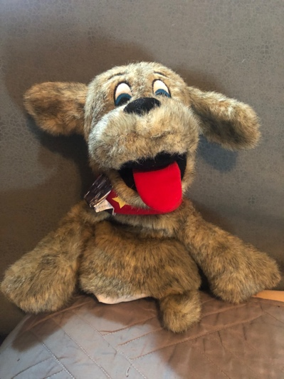

If you had the most wonderful dog in the world, what would your dog look like? Would everyone’s dog look the same? NO! some would have long ears, some short, different color fur, some may like to swim, some may like to play frisbee.

Just as dogs are different, so are people! Each of you are very special and one of a kind. There is no one else in the world just like you. What makes you different?

Draw a picture of yourself and write 5 things you like about yourself.

Work with a family member to see what makes you different!
