Lesson 6 : Staying on the trail to a peaceable place
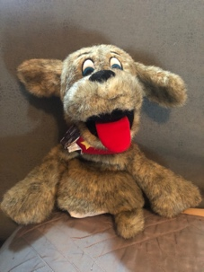
Wagner is having a problem with a classmate “Bully” the bulldog. Bully keeps taking Wagner’s toys at recess. He is bigger and tougher than Wagner and Wagner is scared. Bully called Wagner a scaredy cat and said he would bite him if he told anyone. What should Wagner do?
That’s right! Tell a grown-up!
There are many ways to say NO to something you do not want to do.
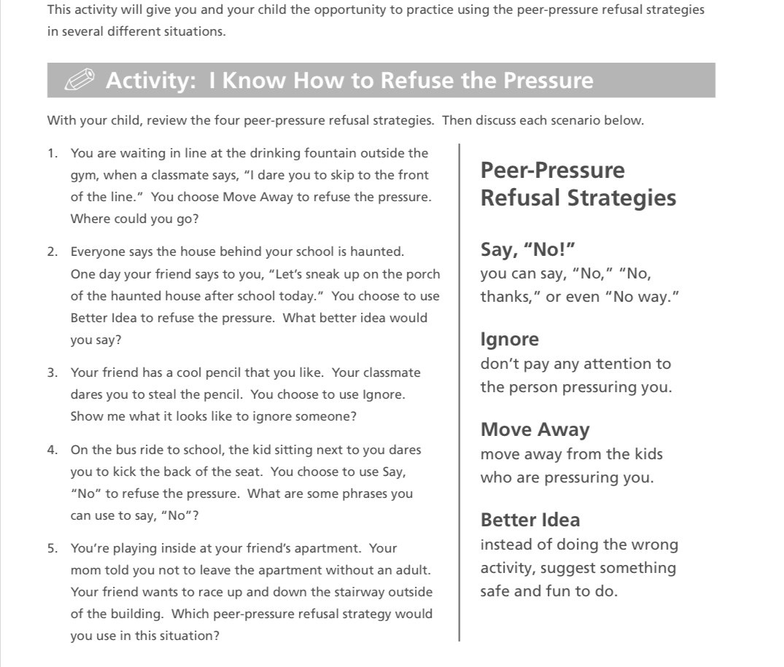
Sounds like Bully the bulldog is acting like a bully. A bully is someone who frightens, threatens, or hurts other people again and again.
We want to keep our homes, classroom, and school PEACEABLE so if you know someone who is being bullied tell your friends, teachers, and parents so we can help! To help Wagner stay on the path to a peaceable place, complete (or review) the worksheet below. Color the things that Wagner should take with him on his path to a peaceable place.

