Lesson 7: Celebrating Our Success

Wagner is almost ready to continue his journey to a peaceable place. Let’s fill in a progress report now so he can see how far he has come.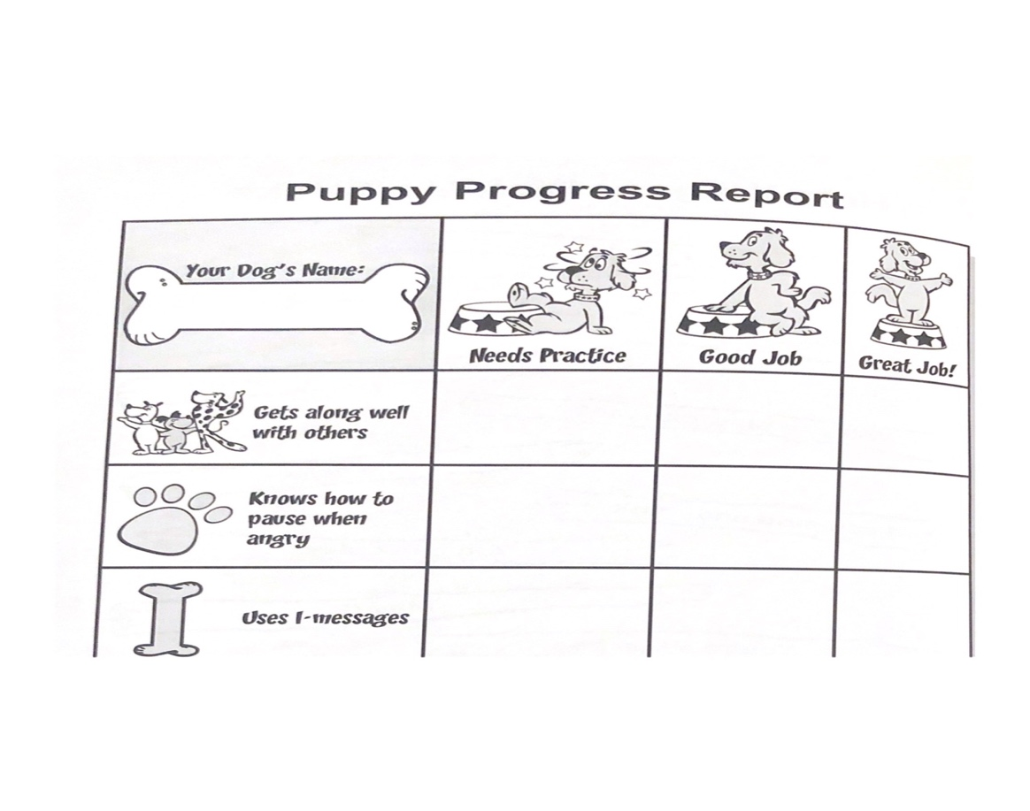

We have finished our course and have learned how to make our classroom and homes a peaceable place! Practice STOP, I-Messages, and being a good friend. Keep using these skills to be the best peacemakers you can be!

